Children’s involvement in bold.
Song: All together as a family - BBC Teach

MONDAY | THEME  COMPASSION | Learning Intention  Noticing a need. | RESOURCES  Roots and fruits p 33,34. Look at the acrostic for COMPASSION on p 34 and focus on NOTICING A NEED. Ask what this means?  We can easily be so busy with the things that we can to do, the games we want to play and the people we want to speak to that we fail to notice when someone needs our help.  Sometimes perhaps we even ignore people on purpose who need our help! We think that helping my change our plans or hold us up.  Have they ever seen anyone hurt and people ignored them?  What Is the Bystander Effect? – Only watch first minute or so with the animated image. Talk about the fact that when lots of people are around, we often don’t step into help. Why?
TUESDAY | COMPASSION | Noticing a need. | Which Bible story demonstrates that Jesus taught us not to ignore others in need?  The Good Samaritan p 37 Roots and fruits. Luke 10 or God's Story: The Good Samaritan  How can we be a good neighbour to those around us?
WEDNESDAY | COMPASSION | Noticing a need. | 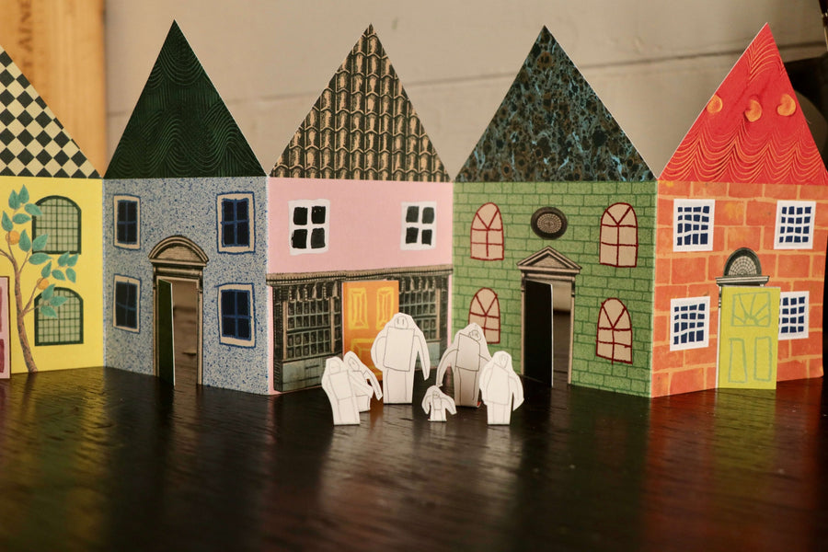  Have a street of folding houses (or ask an older child to make) .  Look at the words to When I needed a neighbour? P 38 and what this means.  When a child shows that they are being a good neighbour – in school or in the community stick a kindness is my superpower sticker on the street of houses. Keep on worship table.
THURSDAY |  |  | CELEBRATION WORSHIP
FRIDAY |  |  | SCHOOLS TOGETHER AT ST GILES’ CHURCH, HARTINGTON – ELIZABETHS STORY

