VE Day home learning project

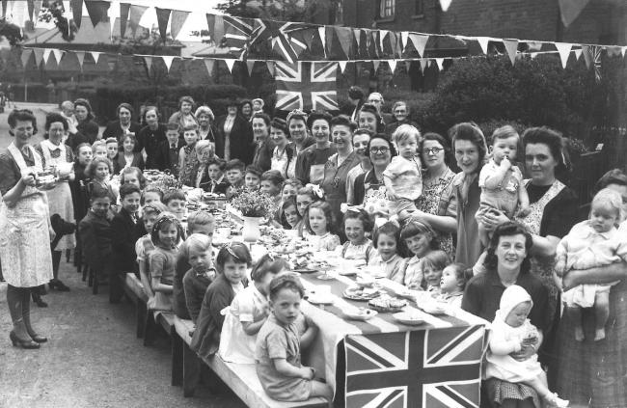
What is VE day?
VE day stands for victory in Europe and marks the end of the Second World War in Europe on the 8th May 1945. Although, this does not mark the end of the war, as the war continued in the Pacific against Japan and it officially ended in September.
Why is it significant?
This question can be interpreted in two key ways. First, the allied countries had achieved victory in Europe and the end of World War Two was in sight. Secondly, we must not forget the millions of people who lost their lives due to war.
How can we remember it?
The most important thing to remember is that we are not celebrating war. We are remembering those people who fought, died and contributed to the war effort.

For the tasks, I have used the following key
Ready – Choose these if they’re tricky Steady – Choose these if you’re confident Go! – Choose these if you need a challenge

Step 1: Introduction and setting the scene

To complete these activities, it would be useful to print off or be able to see the photos on the resources page.

- Watch the clip up to 4.18. (This is a You Tube video of Winston Churchill).

Questions to discuss:

What do you notice about the video? Why is it in black and white? Are their clothes different? What do you think they are doing? How do you think they are feeling? Some people are singing the Lambeth walk. Listen to them singing again. Does the song sound different to the songs we listen to today? Collect your ideas around the picture of the clip.

This week we are going to be learning about VE day. Friday 8th May is a bank holiday because it is the 75th anniversary of Victory in Europe. Look at the timeline on the resources page. What do you notice about the timeline? Is VE day within living memory? Who do you think would remember VE day? Can you create your own timeline and put family members on to the timeline? You will notice that VE day is just within living memory, which means that the people who remember VE day are a lot older.

Activities for you to do:
Ready
On the timeline add your family members of where they would be. Who is the oldest and who is the youngest?
Steady
On the timeline add your family members of where they would be. Who is the oldest and who is the youngest? Can you write in the speech bubble of what is their earliest memory?
Go!
On the timeline add your family members and where they would be. Who is the oldest and who is the youngest? Can you write in the speech bubble of what is their earliest memory? Can you add on topics that you have learnt about? For example, where would Scott of the Antarctic go? Where would you put Henry Vlll? Where would The Great Fire of London go?

Step 2 Children find out and collect information in interesting and varied ways

We learn about history in different ways. We can find out about the past in different ways. We can look at sources from the past such as artefacts and letters. We can also look at sources of information such as books and the internet. We can then ask questions about what we see.

Our enquiry is: How is VE day remembered by the people who were there?

- Gallery (you can either look at these on the screen or print them out)

Questions to discuss:

Have a look at the photos of VE day. What do you notice about the photos? What are they wearing? Are they dressed up? Is the photo in colour? Who is in the photo? What else can you see?

Now read the diary entry from someone who was there from the BBC archives.

What can you learn from reading this person’s experience?

Activities for you to do:
Ready
Say what you have spotted from the photos and the diary entry.
Steady
Write down the information that you have gathered from the photos and diary entry about the VE day celebrations. Can you write questions about these photos? For example, why is there not many men in the photo?
Go!
Write down the information that you have gathered from the photos and diary entry about the VE day celebrations. Can you write some questions about these photos? For example, why is there not many men in the photo?
Can you find any sources yourself using the internet? is there anyone you know in your family that you could talk to who might remember celebrating VE day?

Step 3 Children process the information:

Looking at the photos and the diary entry. Can you spot any similarities between the accounts?
Is there anything in the diary that you can see in the photos? Is there anything that is not mentioned in the diary entry that you can see in the photos? For example, in the diary she mentions bunting and in the photograph there is bunting.

Activities for you to do:
Ready
Spot the similarities between the photos and talk about them.
Steady
Using the grid provided, list the similarities and differences between the photos and the diary account.
Go!
Using the grid provided, list the similarities and differences between the photos and the diary account. Does this make one source more reliable than the other? Why is it a good idea to research information from more than one source?

Step 4 Children draw their own conclusions

Curator’s dilemma
We have been thinking about the significance of VE day and how the people who were there remember VE day. If you were to create your own VE day exhibition, what would you put in it and why?

Have a look at the photos. You can choose 3 photos. Why have you chosen those photos? Can you explain how they help us understand what VE day is and how people remember VE day?

Activities for you to do:
Ready
Choose 3 photos that you would put in your exhibition.
Steady
Choose 3 photos and talk about why you have chosen them.
Go!
Choose 3 photos and explain why you have chosen them. Can you also explain why you did not choose the other photos? What else could you put in your exhibition other than photos?

Step 5: Understanding is checked and secured:

Look at the ‘Who wants to be a millionaire?’ power point.

Have a look at the photograph on slide one and decide which description fits best to the photo.
Activities for you to do:
Ready
Match the explanation to the photo
Steady
Match the explanation to the photo. Could you write a fact file to go with the photo?
Go!
Match the explanation to the photo. Using your historical skills, could you find out more about Winston Churchill? Why is he significant? Write a mini biography of Winston Churchill and include significant event in his life. Use the biography template provided if you wish.
Step 6. Pupils create their own imaginative product
Create your own VE day celebration for your family.

Organise a mini ‘street’ party at home to celebrate the news with your family! Find out what people did at street parties after the war. What will you need to organise?

- Write a letter or invitation persuading your family to come to the party!
- Design and make your own bunting to decorate the house. Remember to ‘make do and mend’! Click here for instructions for how to make Great British Bunting.
- What will you have to eat? Decide what you could make – but remember rationing is still in place and will be for a long time after the War! Perhaps you could bake an eggless cake to celebrate the end of the war.
- Decide what music and songs will be played or sung at the party. Can you practice your favourite song of the time to perform?
- It’s party time! Make sure you wear your Sunday best! Perhaps you would like to make a flag or a banner to wave?
- My word! People were celebrating all over Great Britain! Look at the pictures taken… How do you think people were feeling? Click the link to find out. VE day celebrations

