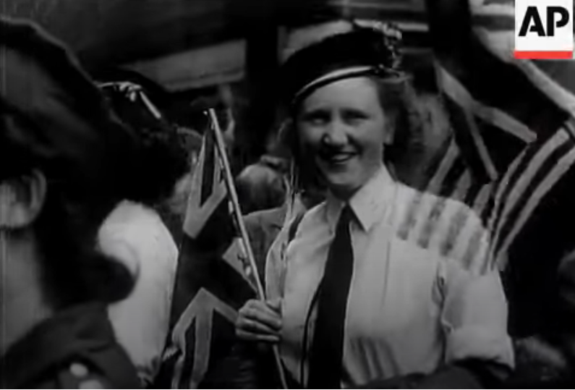

**Screenshot from the video clip for step 1**

Timeline for step 1

Now

VE Day 1945

Beyond living memory

Living memory

Child’s living memory

Adult living memory

Grandparents, older adults living memory

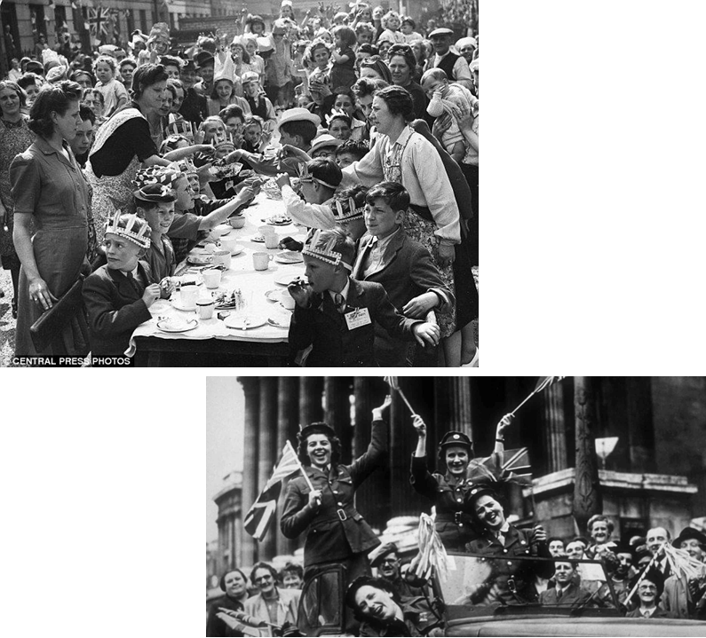  
Step 3: similarities and differences

Step 2 gallery photos

|  |  |
| --- | --- |
|  | **Similarities** |
|  | **differences** |

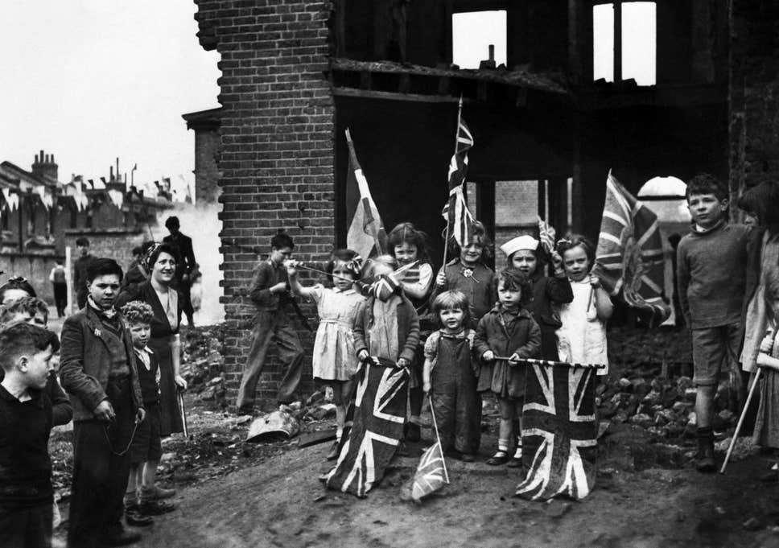

Curator’s dilemma

